Start of series production of hot water heat pump in Faulquemont
- Vitocal 262-A now climate-friendly with natural refrigerant R290
- Efficient and convenient thanks to integration with Viessmann One Base
- Silent mode operation and high efficiency (COP higher than 4 in recirculation mode)
Faulquemont/Allendorf (Eder), 11.04.2024 - A great day for the Viessmann Climate Solutions (VCS) site in Faulquemont (France). The Vitocal 262-A hot water heat pump is now being produced in series and is available to all market partners in Germany, Austria, Switzerland and France. Other countries and propane-based domestic hot water heat pump models will follow this year. Once series production of all hot water heat pumps has been ramped up, more than 30,000 units are to be manufactured per year. As a leading provider of intelligent energy systems, VCS is taking another important step in the transformation away from fossil fuels towards renewable energy sources with the production of heat pumps at an additional site within the company. Comparable transformation projects are running in Landsberg am Lech and in Berlin. The development of the new generation of heat pumps also involved cross-border cooperation between R&D teams in Germany (Allendorf - Eder), Poland (Wroclaw) and France (Faulquemont). Viessmann Climate Solutions is a part of Carrier Global Corporation (NYSE: CARR), global leader in intelligent climate and energy solutions.
Cost-effective and energy-saving
The Vitocal 262-A DHW heat pump utilizes the heat from the outside air or from the recirculating or extract air for DHW generation in a cost-effective and energy-saving manner, thereby making it an ideal addition to the existing heating system. It can be installed in place of a conventional drinking water storage tank. The heat pump is now available with the natural refrigerant R290.
Climate-friendly and future-proof thanks to natural refrigerant
The cooling circuit of the Vitocal 262-A is filled with the natural refrigerant R290, which has a particularly low GWP100 value (Global Warming Potential) of 0.02. This means that the Vitocal 262-A fulfills the requirements of the latest European F-Gas Regulation and ensures efficient operation for many years.
The high coefficient of performance (COP) of 4 in recirculation mode (types T2E/T2H-R290) stands for low energy costs and a high level of efficiency. In addition, self-generated electricity from a PV system can also be used.
Efficient and convenient thanks to Viessmann One Base
Connectivity Inside allows seamless integration of the Vitocal 262-A into the Viessmann One Base platform. This allows the entire heating system to be operated via the ViCare app. Specialist installers can keep an eye on the system online via the ViGuide digital service tool at the operator’s request and correct any irregularities.
Three variants to meet every need
Typical installation locations for the Vitocal 262-A include heating rooms in which a lot of heat is typically generated.
The hybrid version of the Vitocal 262-A – complete with integrated heat exchanger – is available for integration into oil, gas, biomass and district heating systems. It can replace an existing DHW cylinder so that the heating system can be turned off during the warm season.
The electric version is used instead of an electric storage unit. However, it can also be used in combination with a heating heat pump and ensures completely self-sufficient DHW generation.
The wall-mounted version is recommended for combination with hot water, combined or energy storage systems.
Intelligent control of DHW generation
The intelligent control of the Vitocal 262-A hot water heat pumps selects between heat pump and heat generator operating modes, taking into account energy prices and heat pump output values. The Vitocal 262-A preheats the water in the integrated 300 liter cylinder. The existing heat generator is used to maximize hot water convenience for auxiliary heating if required.
Benefits for trade partners
- Integrated carrying handles ensure easy transport
- Installation in low-ceiling rooms possible (up to 2 m)
- Guided commissioning and remote monitoring of the connected Vitocal 262-A using ViGuide by a specialist installer
- Quick heating function with immersion heater (optional for Vitocal 262-A, T2H-R290/T2W-R290)
- Heating of drinking water temperature to a maximum of 70°C with the immersion heater or heat generator
- Anode current measurement automatically issues a notification about upcoming maintenance needs
Benefits for users
- Protects the environment and climate thanks to natural refrigerant R290 with a low GWP100 value of 0.02
- Natural refrigerant R290 enables a flow temperature of up to 65°C, significantly reducing operation of the immersion heater
- Wide range of applications for outdoor air operation – Vitocal 262-A can be used in air temperatures ranging from -10 to +42°C
- Efficient operation and low energy costs thanks to cooling circuit with new Viessmann condenser technology (COP 4)
- Quiet operation due to low noise emissions (additional silent mode option)
- Prepared for optimized consumption of self-generated PV electricity
- The status of the cylinder protection anode is monitored electronically via the Viessmann control unit
- Easy operation via ViCare app
Technical specifications
- Coefficient of performance (COP): 4 (types T2E/T2H-R290, in recirculation mode)
- Weight: 145/160 kg (types T2E/T2H-R290),
44 kg (type T2W-R290)
- Dimensions (depth x width x height): 765 x 667 x 1848 mm (types T2E/T2H-R290),
738 x 668 x 464 mm (type T2W-R290)
- Energy efficiency category: A+ (types T2E/T2H/T2W-R290)
Delivery date
The new Vitocal 262-A with natural refrigerant R290 is already available.

Images/captions
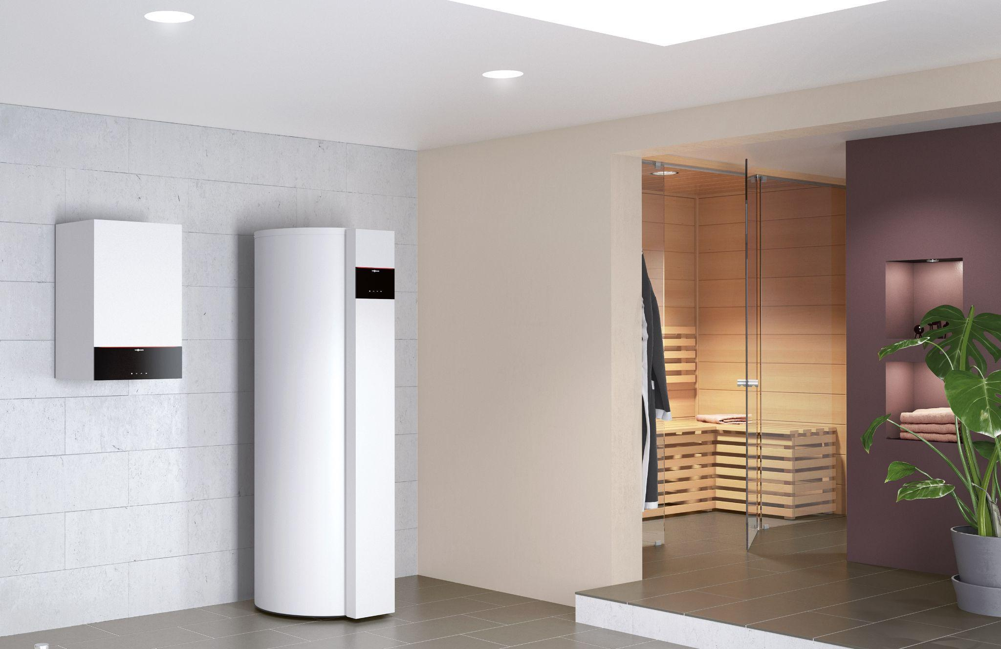
Image 1: Now with natural refrigerant R290: The Vitocal 262-A DHW heat pump uses heat from the outside air or from the recirculating or extract air for DHW generation in a cost-effective and energy-saving manner (shown next to a Vitodens gas condensing wall-mounted boiler).

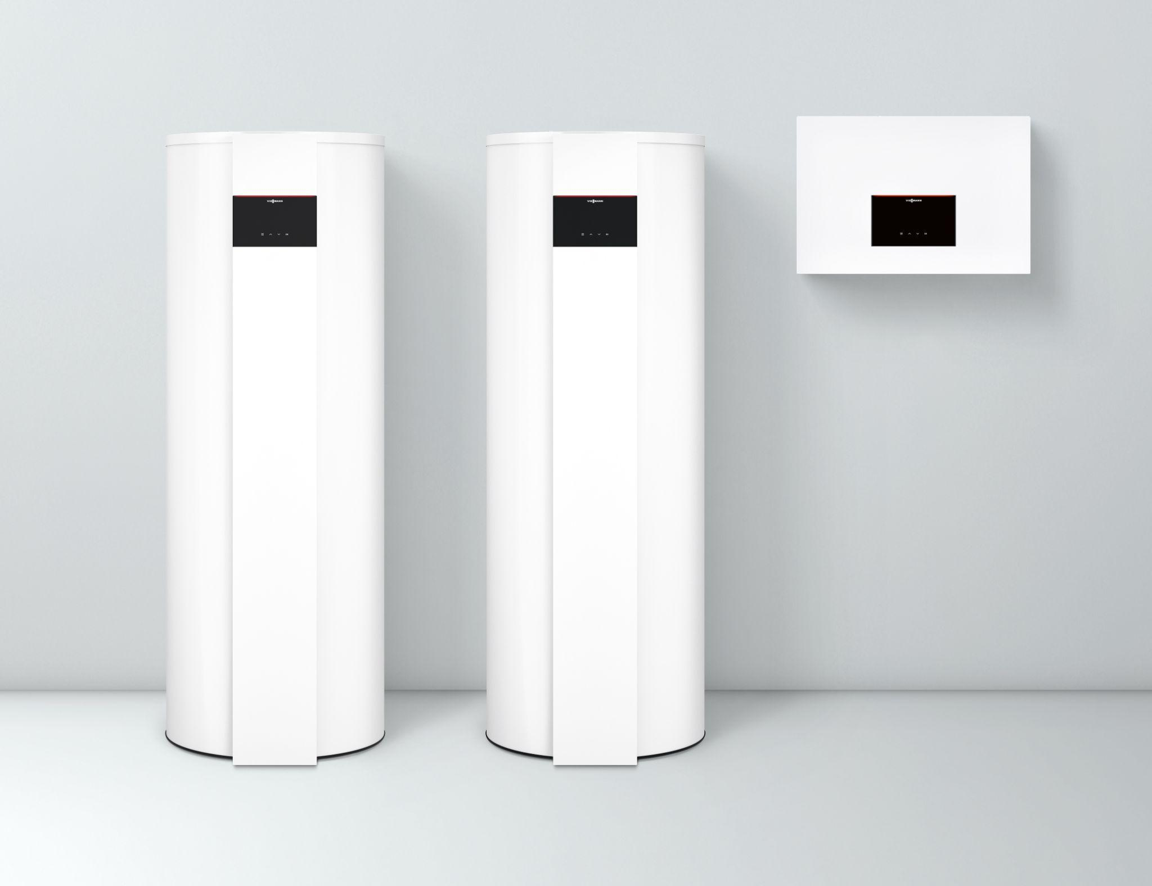
Image 2: Three variants for every need: Vitocal 262-A hot water heat pump with
DHW cylinder (300 liter capacity) and as a wall module.

